BÀI TẬP TIẾNG ANH LỚP 6 (TUÀN TỪ 27/3- 2/4)

- REVISION
* Phonetics:
Diphthongs: /eə/ and /ɪə/
*.Grammar:
- The past simple
.Cách phát âm đuôi “ed”:

Đuôi “ed’ được phát âm theo ba cách khác nhau:
-/id/ sau các âm /t/ và /d/
-Eg: wanted, decided
-/t/ sau các âm vô thanh(f,s sh,ch,p,x,k)
Eg:washed, stopped
-/ d/ sau các âm còn lại và nguyên âm.
Eg: lived, traveled……
* Imperatives (Câu mệnh lệnh)
Là câu dùng động từ để ra lệnh
Form:
(+) V + object!
Eg: Open the book!
Go out!
(-) Don’t + V + object!
Eg:Don’t eat too much chocolate!
*Vocabulary
Nouns and verbs related to sports and games

- EXERCISES
- Give the name of the following, then read the words aloud (the first letter of each word is given)

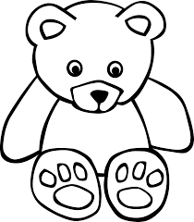
- b______________

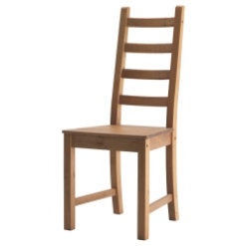
- c______________

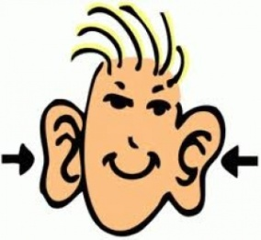
- e______________
- p______________

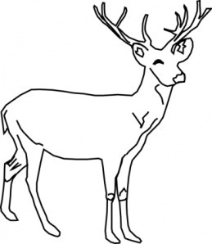
- d______________

- h______________
- b______________

- t______________

- c______________

- s______________

- Read the conversation. Then single-underline the words with sound /eə/ and double-underline the words with sound /ɪə/
Mary: I’ve lost two small hairbrushes, Claire. They’re a pair.
Claire: Have you looked carefully everywhere?
Mary: Yes. They’re nowhere here.
Claire: have you looked upstairs?
Mary: Yes. I’ve looked everywhere upstairs and downstairs. They aren’t anywhere.
Claire: Hm! Are they square, Mary?
Mary: Yes. They’re square hairbrushes. Have you seen them anywhere?
Claire: Well, you’re wearing one of them in your hair, near your right ear!
Mary: Oh, dear! Then where’s the other one?
Claire: It’s over there under the chair.
- Label each of the following pictures with correct name of the sports and games. Use the words in the box

fishing cycling tennis skiing volleyball
swimming badminton football running table tennis

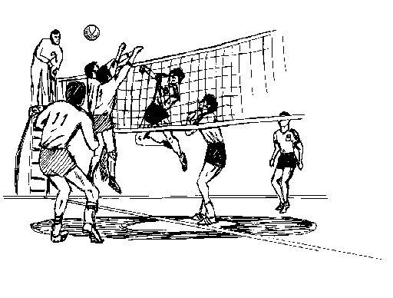
- _______________________
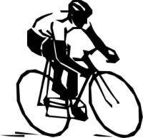
- _______________________
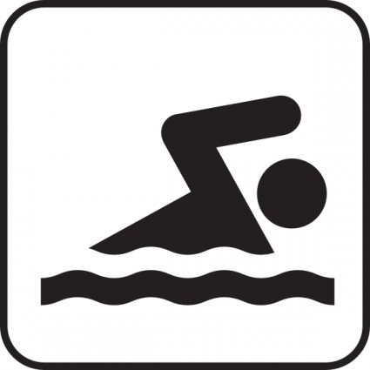
- _______________________
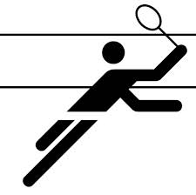
- ______________________
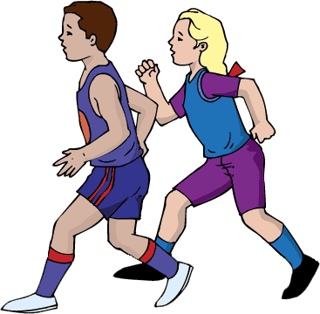
- ______________________
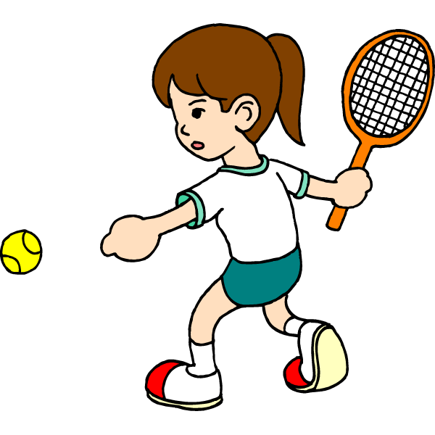
- ______________________
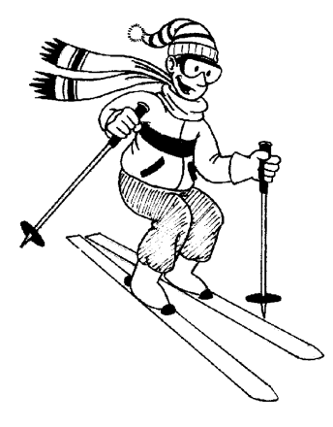
- _____________________
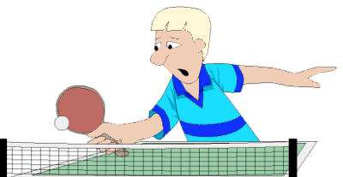
- _____________________
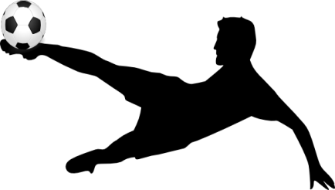
- _____________________

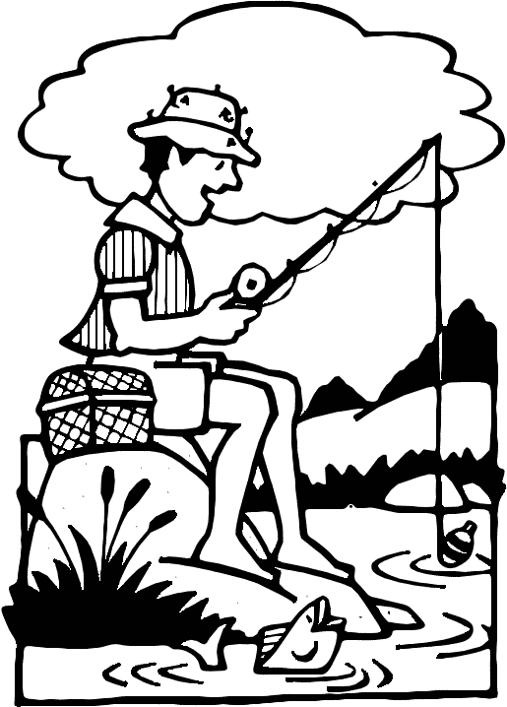
- _____________________

- Give the correct form of the words given to complete the sentences.
- Stories about ___________ people in the world of sports are often FAME
very interesting.
- When you open a newspaper, you’ll always find _________ about INFORM
some games.
- Huy’s brother is a _________ football player, isn’t he? PROFESSION
- Please listen to the ________ carefully. INSTRUCT
- Did you join the sports __________ last week, Tom? COMPETE
- _____________ ! Your team won the first prize. CONGRATUALTE
- The _______ in this gym is very modern. EQUIP
- I think sports and games are very _________ . USE
- The football fans cheered ________ for their side. LOUD
- I did many sports last week and was _________. EXHAUST
- Put the verbs in brackets into suitable tenses
- When my brother and I (be) ___________ small, we (go)_________ swimming every weekend.
- Minh (not go) _________ jogging yesterday; she (stay) _________ at home and (do) _________ aerobics.
- Owen is a football coach but he (not work) _________ at the moment.
- You (watch) _________ the tennis match on TV last night?
- Quang (not play) _________ any sports. He (like) _________ collecting stamps.
- My father (take) _________ me to the National Stadium five days ago.

- Choose the suitable imperatives in the box to finish sentences.
- Please fill it out.
- Please don’t open the window.
- Don’t eat candy, and get more exercise.
- Don’t clean my room.
- Please don’t wake him up.
- Go straight for two blocks.
- Please bring me a glass of water.
- Please say that again.
- Please take it to the post office.
- Call me in twenty minutes.
- - “How can I lose weight, Doctor?”
- “__________.”
- – “ ____________.”
- “Ok! Is that all?”
- It’s cold in here! ____________
- Where’s Dad? – He’s taking a nap. ________________.
- The package is ready. _________________
- I’m sorry. I didn’t hear you. ______________
- Here’ s the hotel registration form. _____________
- – “ Maria, it’s almost time to leave.”
- “ I’m not ready. ______________.”
` 9. Excuse me, where’s the travel agency? - ____________

